Homework 6

Link to code: https://github.com/bhavyamg1234/Homework-6.git
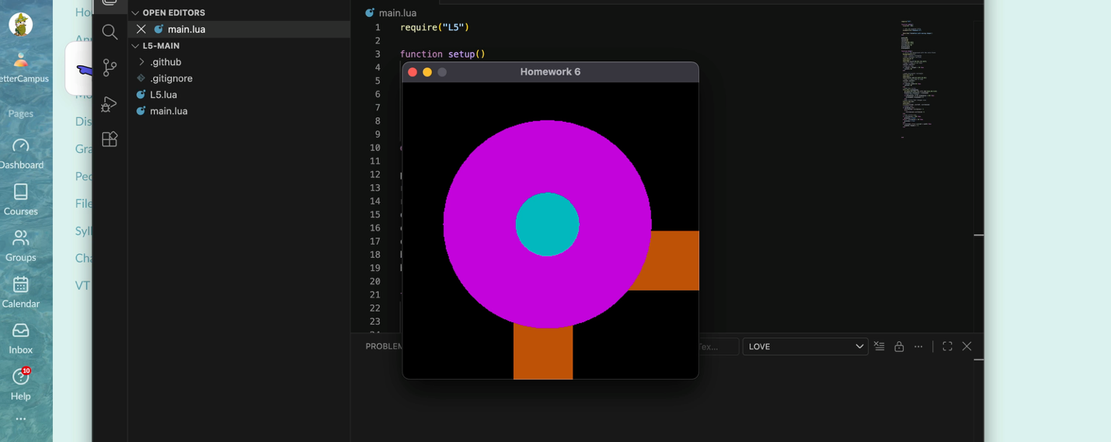
Video of the process:

Brief Explanation:
I wanted to make the work visually interesting by adding a variety of shapes. The two rectangles differ from two circle and create visual interest. I also wanted to make one shape and have the shapes interact with each other as one combined shape. I also think that the neon color palette unifies the work and makes the shapes look cohesive.

Code:
require("L5")

function setup()
size(400, 400)

-- Set the program title
windowTitle("Homework 6")

describe('Animation with moving shapes')
end

posX=200
rect1X=50
rect2Y=50
circleX=195.6834
circleY=191.1773
circlesize= 90
bluevalue=0
bluespeed=5

function draw()
-- Fills the background with the color black
background(0,0,0)
--make looping rectangles
--make rectangle vertical
fill(191,82,8)
noStroke()
rect(150,rect2Y,80.052,324.8675)
--make it move up and down
rect2Y= rect2Y+1
--make it loop
if rect2Y > height + 30 then
rect2Y= 50
end

--make horizontal rectangle
fill(191,82,8)
noStroke()
rect(rect1X,200,324.8675,80.052)
--make it move side to side
rect1X= rect1X+1
--make it loop
if rect1X> width+30 then
rect1X= 50
end
--make big circle
fill(196,5,bluevalue)
ellipse(195.6834,191.1773,280.5128,280.5128)
bluevalue= bluevalue + bluespeed
--loop color change
if bluevalue < 0 or bluevalue > 255 then
bluespeed= bluespeed *-1
end
--make circle that changes size
fill(6,184,193)
noStroke()
circle(circleX, circleY, circlesize)
--change size
if growing then
circlesize= circlesize + 1
else
circlesize= circlesize -1
end
--loop circle size
if circlesize > 100 then
growing = false
elseif circlesize < 50 then
growing = true
end
if circleX < 0 or circleX > width then
Xspeed= Xspeed * -1
end

end

